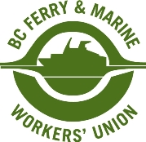

**Photo release form**

***MEMBER/EMPLOYEE NAME:***

_________________________________ ____________________________________

First Last

_____________________

Employee (Member) Number

I grant permission to the BC Ferry & Marine Workers’ Union to take and use photographs and/or video recordings of me for union communications, including print materials, newsletters, presentations, websites and social media.

I understand these images may be used without further notice or approval and may be seen by the public. I release union from any claims related to the use of my image, including claims for compensation, defamation, or privacy violations.

I have read and understood this release.

**Consent**  ☐ Yes    ☐ No

**Signature**  ____________________________________  **Date:** ____________